How to install Facelock on Windows OS

1. Source Code:



******************************Amazon Ubuntu Instance Setup **************************

************************************************************************************

1. cd /Users/zeboxiong/Desktop/AWS
2. ssh -i "facelock_zebo.pem" ubuntu@ec2-18-222-110-11.us-east-2.compute.amazonaws.com
3. sudo apt install python2 /** install python2 &3 **/
4. sudo apt install python3
5. Which python2.7 🡪 /usr/bin/python2.7 /** install pip2 & 3 **/
6. wget <https://bootstrap.pypa.io/get-pip.py>
7. sudo python2.7 get-pip.py
8. sudo apt-get update /** update **/
9. sudo apt-get -y install python3-pip
10. sudo pip2 install cmake /** install CMake **/
11. sudo pip2 install dlib
12. Follow this link: <https://www.learnopencv.com/install-dlib-on-ubuntu/>
13. sudo pip2 install dlib
14. pip2 install Django
15. “sudo pip2 install cmake” (Action: install cmake)
16. Run “pip2 install face_recognition”
17. Run “pip2 install opencv-python” (Action: Install openCv)
18. Run “sudo pip2 install --upgrade google-api-python-client” (Action: to configure google vision api)
19. Run “sudo pip2 install --upgrade google-cloud”
20. Run “sudo pip2 install --upgrade google-cloud-vision”
21. Run “sudo pip2 install **scipy**” (Action: Install scipy)
22. Run “**pip2 install PyHamcrest**”
23. Run “sudo pip2 install argparse”
24. From Local Mac Computer:

scp -i facelock_zebo.pem facelock_2.0.zip ubuntu@ec2-3-14-247-124.us-east-2.compute.amazonaws.com:facelock_2.0.zip

scp -i facelock_zebo.pem key.json [ubuntu@ec2-18-188-224-213.us-east-2.compute.amazonaws.com:key.json](mailto:ubuntu@ec2-18-188-224-213.us-east-2.compute.amazonaws.com:key.json)

1. sudo apt-get install unzip /** install unzip software **/
2. sudo apt-get install **lxde** -y /** install GUI **/
3. sudo apt-get install xRDP -y /** remote (BUT it is for Windows) **/
4. sudo systemctl enable xrdp /** **/
5. sudo apt-get install vinagre /** 遠程操作client **/
6. sudo apt-get install ubuntu-desktop /**製作界面**/
8. sudo apt install x11vnc
9. x11vnc -storepasswd /** 設置密碼 **/
10. x11vnc -usepw
12. [Solution](https://www.edyoda.com/watch/DE287FF9E60B105231FD5B6C067443176CE995B17B707DA151/) (Host Django on Amazon Ubuntu)
13. cd facelock_2.0/facelock/facelock2/facelockproj/
14. python2 manage.py runserver 172.31.6.236:8787 Here is the Private IP

<http://18.188.224.213>:8787/ 🡪 connect using Public IP

2. Error one: “Invalid HTTP_HOST header: **'3.14.247.124**:8000'. You may need to add u'3.14.247.124' to ALLOWED_HOSTS.” 🡪 [Solution](https://stackoverflow.com/questions/40582423/invalid-http-host-header)
3. Update settings.py 🡪 update “Allowed Host”



1. 
2. <http://172.31.6.236:8000/> 🡪 Open the browser
3. set 🡪 check environment variable in Linux
4. echo "$HOME" 🡪 Check variable HOME ‘s value /** 設置環境變量 **/

export GOOGLE_APPLICATION_CREDENTIALS=/home/ubuntu/key.json

1. echo “$GOOGLE_APPLICATION_CREDENTIALS” 🡪 打印變量
2. You have to setup Google API billing to activate your key!!!

************************************************************************************

************************************************************************************

1. Install Dlib Python API on Windows PC <https://www.youtube.com/watch?v=Q4_M8YTAPDg>

* Follow EVERY step in this video.

1. Install Python 2 (Such as Python 2.7.15 <https://www.python.org/downloads/release/python-2715/> )
2. Run this command: “pip install Django”

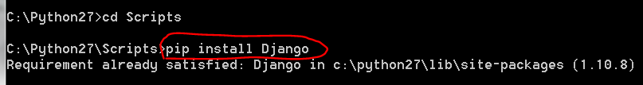

1. Run “pip install cmake” (Action: install cmake)
2. Run “pip install face_recognition”
3. Run “sudo pip2 install opencv-python” (Action: Install openCv)

1. Run “pip install --upgrade google-api-python-client” (Action: to configure google vision api)

Rnu “pip install --upgrade google-cloud”

Run “pip install --upgrade google-cloud-vision”

1. Run “pip install **scipy**” (Action: Install scipy)

1. Run “**pip install PyHamcrest**”

1. Run “pip install argparse”
2. Attention: above command must run at path: **C:\Python27\Scripts** (Not necessary Python27, but must be in Python **2** ), and using “**Anaconda Prompt**”
3. Add PATH (Google Cloud API)

* GOOGLE_APPLICATION_CREDENTIALS
* facelock-aee2366fc392.json file

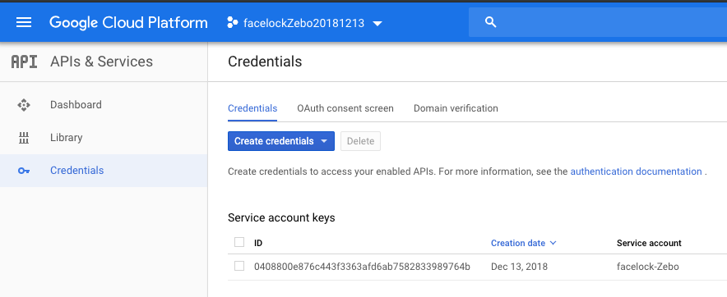

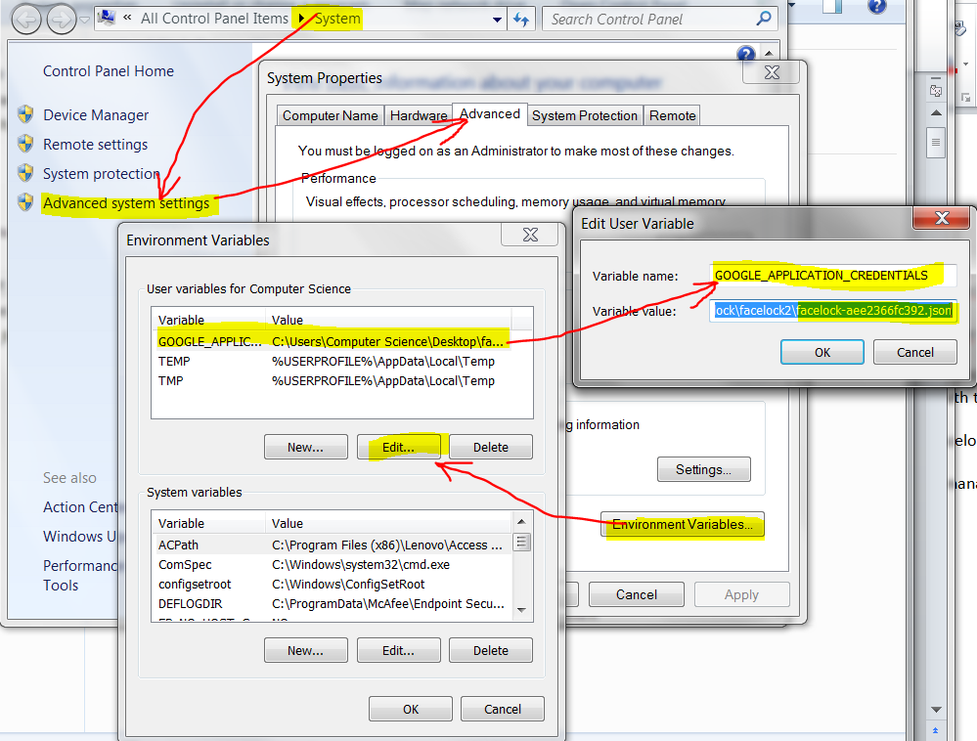

1. Keep below JSON file updated via Google Cloud Account.

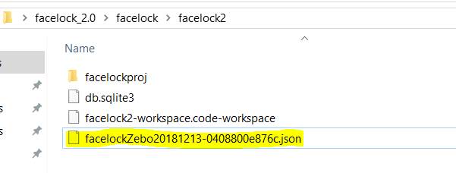

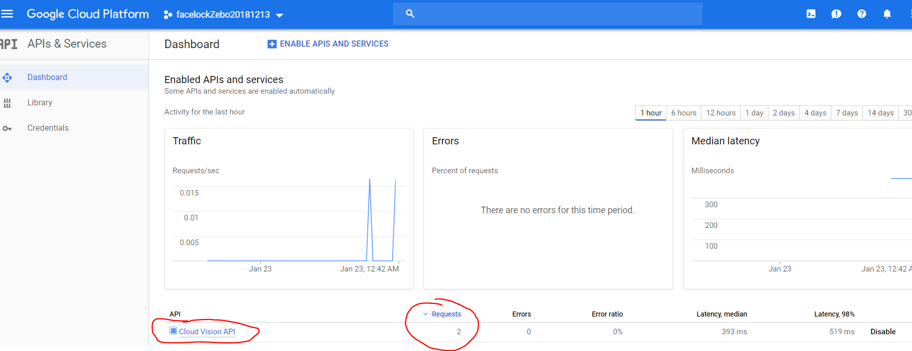

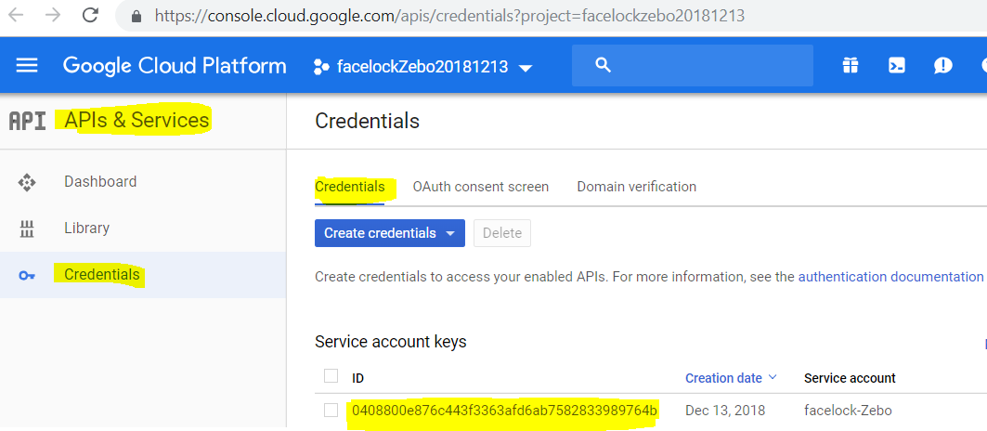

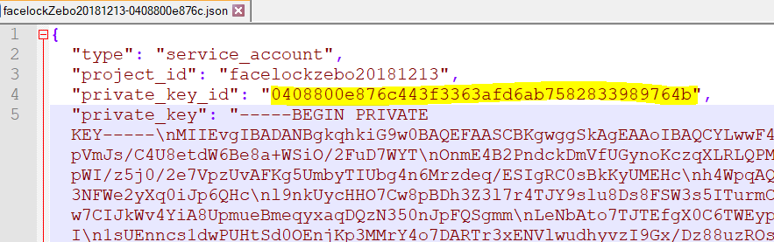

1. Install “DB Browser for SQLite” <https://sqlitebrowser.org/>

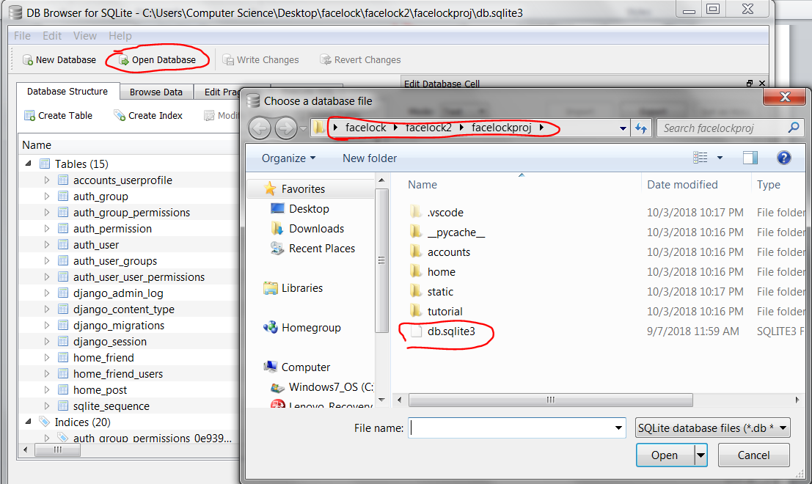

1. Run “python manage.py runserver”

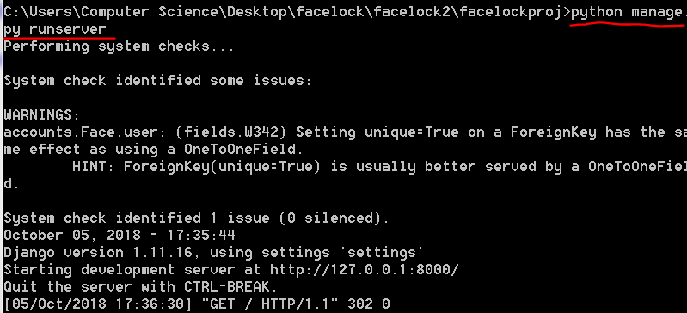

1. Open webpage: <http://127.0.0.1:8000/> and login as:

* Donald Trump: Username: donald | Password: donalddonald
* MelaniaTrump: Username: melania | Password: melaniamelania
* Barack Hussein Obama: Username: obama | Password: obamaobama
* Michelle Obama: Username: michelle | Password: michellemichelle
* Hillary Clinton: Username: hillary | Password: hillaryhillary